Topic B Project – Due Tuesday 9/23

When payments are being made on a loan, it is often of interest to know what the remaining balance is at a given time during the life of the loan. This would be the payoff amount (without any additional fees, costs, etc.). That is, the remaining principal on the loan. (Bank loan payments are divided into interest and principal, with the interest being predominant initially. Gradually the interest part gets less and less and the principal part of the payment increases.)

The formula used to calculate this is the following:

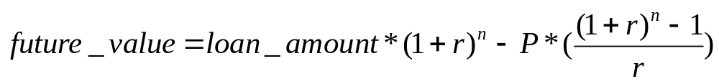

Where:
future_value = The remaining balance of the loan
loan_amount = The original loan balance
P = The monthly payment amount
n = The number of loan payments already made
r = The interest rate per month

Call your file TopicB.cpp. You may assume that only numbers will be input, not strings, characters, etc. That is, all the input will be correct.

The formula must be a single C++ statement, not divided into smaller pieces. (Exception: Monthly interest can be determined separately and used in the formula.)

Think about what the appropriate data type would be for each component of the formula. Notice from the program output that even though the program has to convert the interest rate to a monthly value for the second formula, it is the annual interest rate that is displayed. As per the Assignment Grading Criteria, use the output shown by the executable I supply. Run TopicB.exe to see what the output should be.

The part of the program that displays "Press Enter to end" is part of your assignment. Remember that this should come from your program. "Press any key to continue…" comes from Visual Studio, not your program. (You cannot prevent Visual Studio from displaying that line.)

Remember that a program must be general and work for all values, as defined by the problem. For example, do not put values such as 10 for the number of payments directly into your program (this is called hard coding). Your program should be able to handle any reasonable input values. Try running my program with different, correct, values which are different from those shown below. (Since the project does not require any error checking, my solution does not do any error checking.) You can run my solution using TopicB.exe.

Remember that your program should work for any valid input.

I suggest that you first make sure that the program generates the correct values before trying to work on the formatting.

I got this formula from http://www.financeformulas.net/Remaining_Balance_Formula.html. You can use the calculator on that page to verify that your program displays the correct results. Be aware that that website calculator requires the monthly interest. Thus, for a 12% yearly interest rate, you must enter 1% in the site’s formula. For a 9% yearly interest rate, the formula requires .75% as the entry.

You will notice on the website that when you enter 1% as the rate, the formula will display this as 0.01. For the .75% rate, the website formula uses 0.0075. In your program, you will have to convert the yearly interest to a monthly rate (divide by 12) and then convert that to a decimal (divide by 100). Thus, 12 / 12 is 1 and 1 / 100 is 0.01. (The website requires you to do the calculation to get the monthly percentage while your program will be more user friendly and do all the rate conversions.)

For the site’s formula, you can use these values as tests:
PV 100000 90000
P 2000 2000
r 1 (representing a yearly rate of 12%) 0.75 (a yearly rate of 9%)
n 10 10

See what my program displays for these values. (Remember for my program to input the annual percentages.)

Your program should accept any valid numbers as input and calculate a result.

